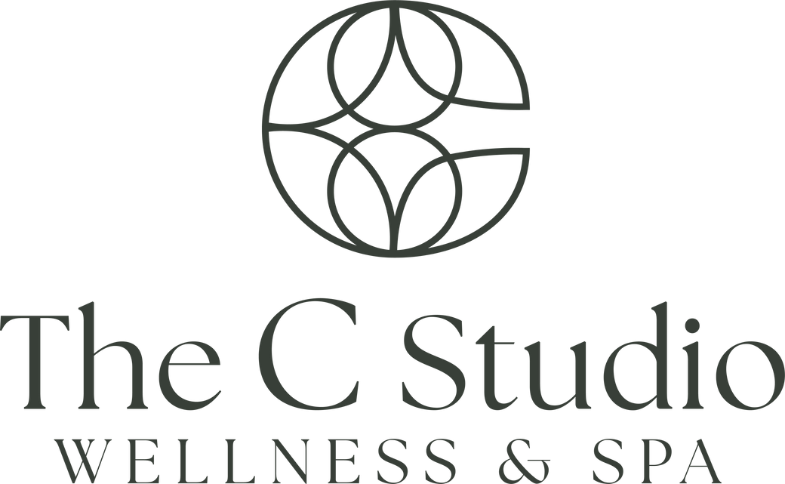

27674 Newhall Ranch Rd C85, Valencia, CA 91355, | tel (661) 812-0251 | thecstudiowellness.com

PRE & POST CARE FOR SKINBETTER CHEMICAL PEEL
Peels should not be performed on pregnant or nursing mothers.

PRE-TREATMENT

- For optimum results, skin may be acclimated to skinbetter science skincare products one to two weeks prior to first peel treatment. Consult with your Healthcare Professional to determine which products are suitable for use.
- Avoid clay masks, scrubs or additional exfoliators that contain alpha hydroxy acids (AHAs) such as glycolic and lactic acid and beta hydroxy acids (BHAs) such as salicylic acid for at least 48 hours prior to each peel treatment.
- Do not use AlphaRet products, Retin-A or any other Vitamin A product, including products that contain a retinoid or retinol for at least 48 hours prior to each peel treatment.
- Do not use self-tanning agents for at least 48 hours prior to each peel treatment.
- If you have a history of cold sores, the AlphaRet Professional Peel should not be performed if active cold sores, fever blisters or herpes are present anywhere on your face prior to treatment. If you are prone to or have a history of cold sores or fever blisters, speak to your Healthcare Professional as they may consider treatment with antiviral medications prior to receiving treatment with an AlphaRet Professional Peel.
- The AlphaRet Professional Peel should not be performed on sunburned or windburned skin.
- Do not have facial hair waxed/lasered 48 hours prior to each peel treatment. Avoid facial hair shaving 8 hours before each peel treatment.
- If you have recently undergone any other facial treatment procedures, such as microdermabrasion, microneedling, dermaplaning, laser resurfacing, chemical peels, botulinum toxin, dermal fillers, facial plastic surgery, etc., skin must be completely healed and normalized prior to receiving an AlphaRet Professional Peel.

Please talk to your Healthcare Professional if you have had any recent procedures to confirm suitability of treatment.

POST-TREATMENT

- Generally, non-comedogenic (non-pore clogging) makeup may be applied after each AlphaRet Professional Peel treatment.
- Avoid exercise (sweating) for at least a few hours after each peel treatment.
- Avoid direct sun exposure; wear protective clothing (i.e. wide-brimmed hat) and use a mineral sunscreen (containing titanium dioxide and/or zinc oxide) with an SPF 30 or higher, daily.
- Do not use retinoid- or retinol- containing products such as Tretinoin, AlphaRet Overnight Cream, or other Vitamin A derivatives for 5 days after an AlphaRet Professional Peel treatment, unless otherwise directed by your Healthcare Professional.
- Do not use other potentially irritating ingredients such as harsh exfoliating products that contain alpha hydroxy or beta hydroxy acids (AHAs [i.e. glycolic and lactic acids] or BHAs [i.e. salicylic acid]) for 5 days after an AlphaRet Professional Peel treatment, unless otherwise directed by your Healthcare Professional.
- If irritation occurs, stop or do not resume use of products until the skin has normalized.
- Facial hair should not be waxed for 48 hours after an AlphaRet Professional Peel treatment. You may resume facial shaving the day after each peel treatment or when the skin has normalized.
- Avoid the use of heat sources such as steam, saunas, professional or home hair dryers for 8 hours following an AlphaRet Professional Peel treatment.

If your provider has given you instructions deviating from the general recommendations in this document, please follow your provider’s personalized instructions.

Questions or concerns? Please call us at (661) 812-0251.

